Visoka škola strukovnih studija za informacione i komunikacione tehnologije u Beogradu

Visoka ICT škola

Web programiranje 2 – Dokumentacija za sajt

Ime I prezime studenta: Marjanovic Aleksandar

<https://github.com/TheHandOfKing/dota2>

<https://thehandofking.github.io/dota2/>

Broj indeksa: 115/17

Decembar 2018, Beograd

Sadrzaj:

1. Uvod

1.1. Korišćeni programski i markup jezici

1.2. Opis funkcionalnosti

1.3. Izgled i kodovi, zajedno sa css-om

2. Organizacija

2.1. Organizaciona šema

2.2. Sitemap

1 Uvod

Sajt za predmet Web Programiranje 2 napravljen je po uzoru na sajt dota2.com uz upotpunjen responsive design-a.

1.1 Korisceni programski I markup jezici

HTML 5, CSS 3, Javascript, Jquery 1.* Pored ovoga korisceni su i font awesome i google ‘Trajan’ font, sve ostalo je radjeno u js-u

1.2 Opis funkcionalnosti

Index.html

Sadrzaj koji se vuce iz jsona, preko ajaxa je u sredisnjem delu strane, gde postoje 3 diva sa informacijama iz jsona. Header je isti na svim stranama I responsive je uradjen, tako da se sadrzaj menja I nestaje u odnosu na velicinu stranice. Svi linkovi vode ka dota2.com stranama. Ispod svega ovoga je carousell, koji ce na uredjajima biti automatski, a na velikim ekranima postoje 4 slike na koje se moze klinkuti, sve ovo je uradjeno u fajlu index.js. Footer je bazican, samo toliko da ima nesto u njemu. Sa gledista html koda, ova stranica ga ima najvise.

Login/Register delovi headera vode ka jednoj strani samo. Imaju id-jeve preko kojih se pamti sta je korsnik kliknuo, I na osnovu toga sta je kliknuo ispisuje se odredjen sadrzaj (Za logovanje ili Registraciju). Ostale strane headera su opisane ispod.

Heropedia.html

Ovo je deo na kome sam najvise radio, I ima ujedino I najvise js koda. Osim okvira, sve ostalo sto postoji na stranici se vuce iz jsona ili je napisano preko javascripta. Heroji koji su stavljeni ovde su podeljeni u 3 kategorije (Strength, Intelligence, Agility). Na osnovu ovih kategorija ne moze da se vrsi filtracija. U njihovom jsonu postoje detaljniji opisi, koji mogu da se koriste kao filteri, ali ne kao filteri za ispis sadrzaja kao u store.html. Ovi tagovi/slike se filtriraju tako sto im se onemoguce event listener za klik, mousein I mouseout, ujedino im se izbrise box shadow I smanji opacity. Treba napomenuti da filteri nisu uskladjeni tako da ako hocemo da dobijemo escape mele heroja, necemo ga dobiti. Dobicemo poslednji filter na koji smo kliknuli. Klikom na moguceg heroja focus ce vas odvesti na hero biography div, u kome ce se ispisati sadrzaj heroja. Prvobitno je sve stajalo tu, sa display:none, jer je ovo bio rani projekat. Sada, kada se poklopi ime, ispise se biografija za tog heroja, poziva se ajax I iz njega se vuce opis heroja. Zajedno sa tim na title se dodaje – <ime heroja>. Event listener za mouse in I mouseout je u pocetku imao par bagova koji su donekle reseni. Ako pomerate misem brzo preko slika, one se nekad prikazu I vise od jedne ili jedna ostane a jasno se vidi da mis nije u njoj. Postoji linija koda koja prati koliko u svakom trenutku ima slika preko kojih se hoveruje, ako ih ima vise od jedne, odmah se sve smanjuju, odnosno display im se stavlja na none.

News.html

U ovom delu postoje 3 json fajla, jedan je za updatove, koji nemaju sortaciju, drugi za postove koji isto nemaju sortaciju, nego stoje samo kao eyecandy. I blog deo koji ima sortiranje po datumu I od a-z. Klikom na updates generise se novi ajax zahtev I ispisuje se sav sadrzaj updates.json fajla. U istom trenutku se dugme za order az I order date onemogucavaju, jer sortiranje za updateove nije potrebno. Oni, opet tu stoje samo zato sto stoje I na glavnom sajtu

Store.html

Store ima 2 dela, cart I svoj store page u kome su uradjeni primeri filtriranja po 3 osobine. Klikom na bilo koju osobinu, generise se novi ajax I generise se novi kod koji se podudara za datom osobinom. Funkcionalnost carta tek treba da se doda, da bi ove 2 strane radile zajedno

Sign.html

Je deo sajta za logovanje I registraciju. Klikom na register ili login, korisnik se vodi na jednu stranu, I na osnovu onoga sto je kliknuo, taj mu se sadrzaj ispisuje. Samo stranica za registraciju ima regex jer login jos nije podrzan. I regex za login nije potreban.

1.3 Izgled

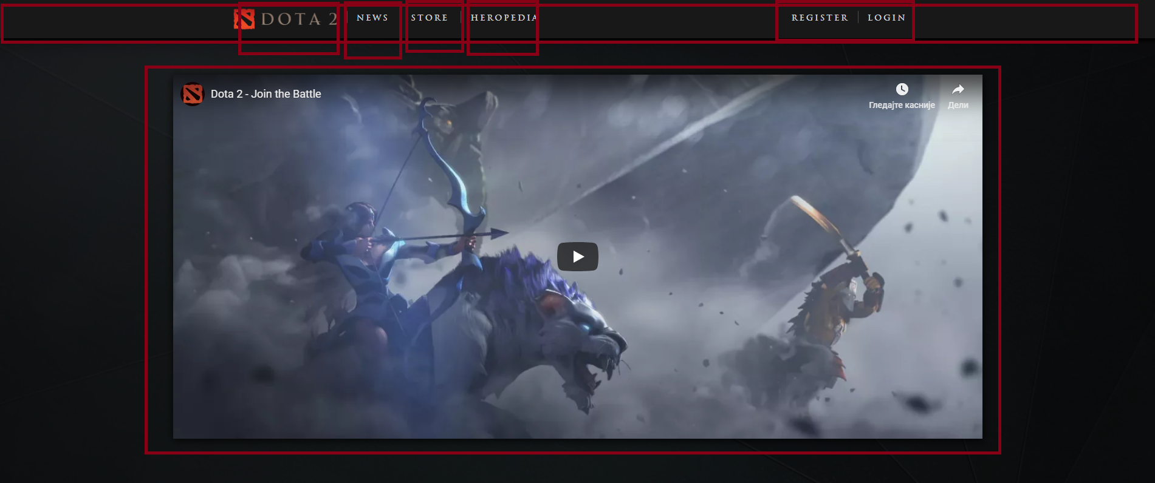

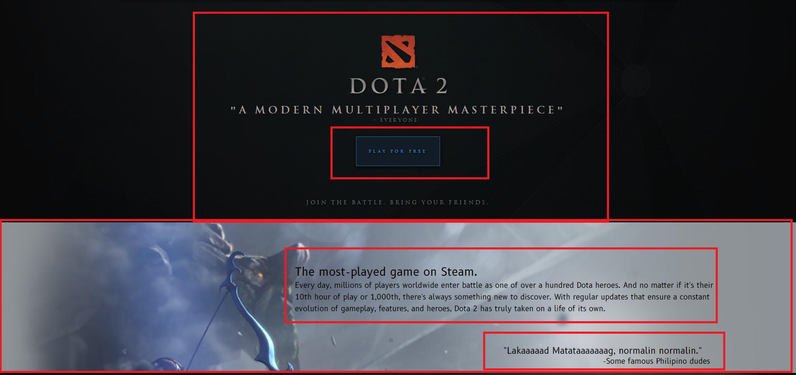

Postoje jos 2 ovakva posta, ovo je samo izgled

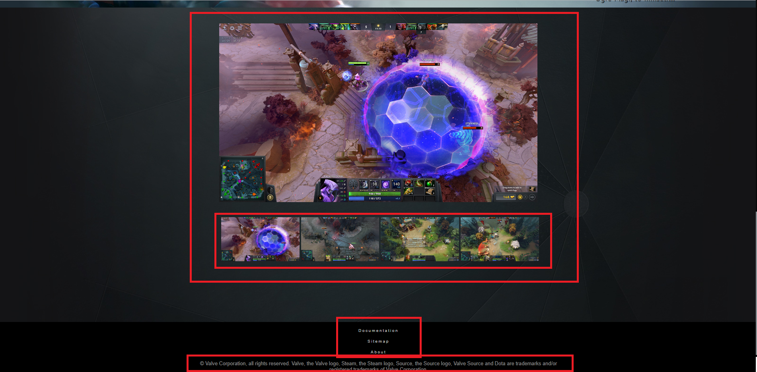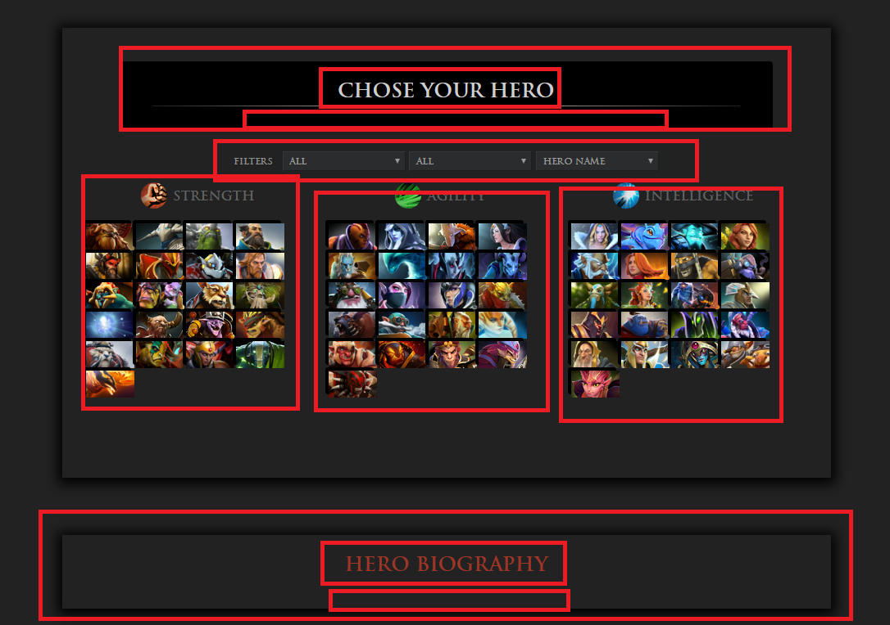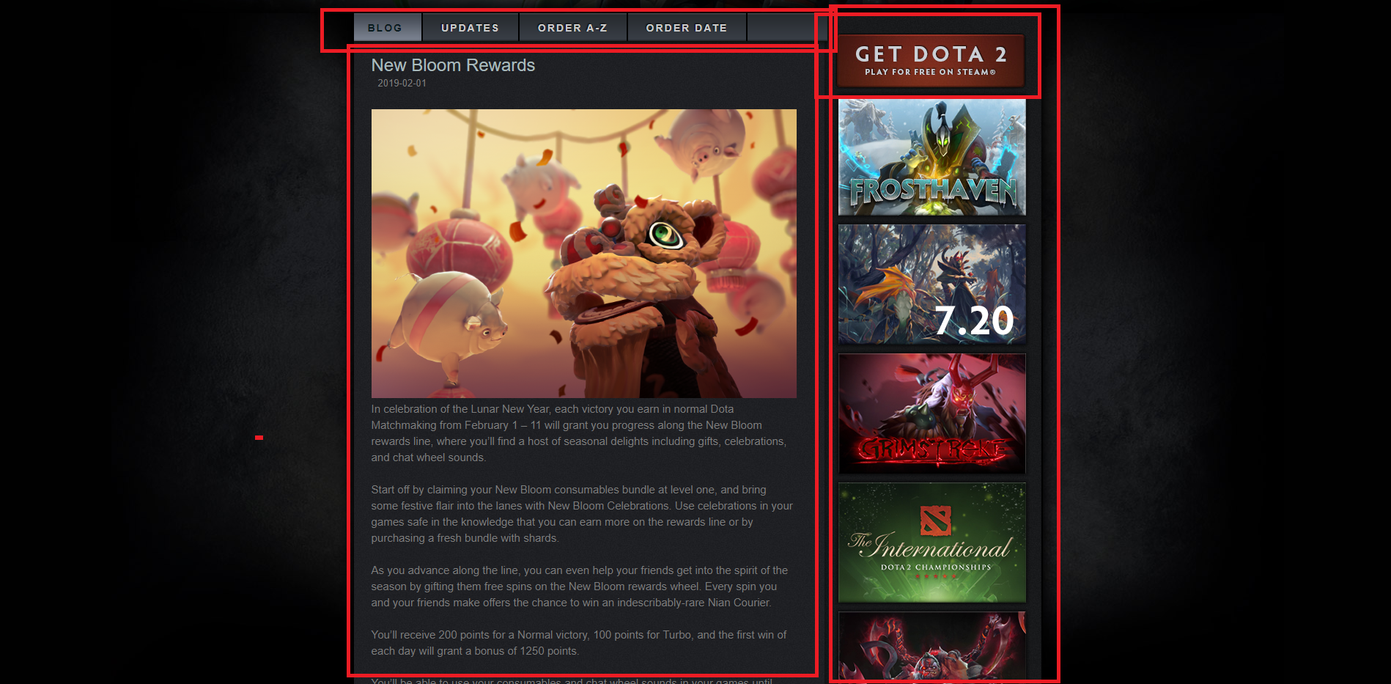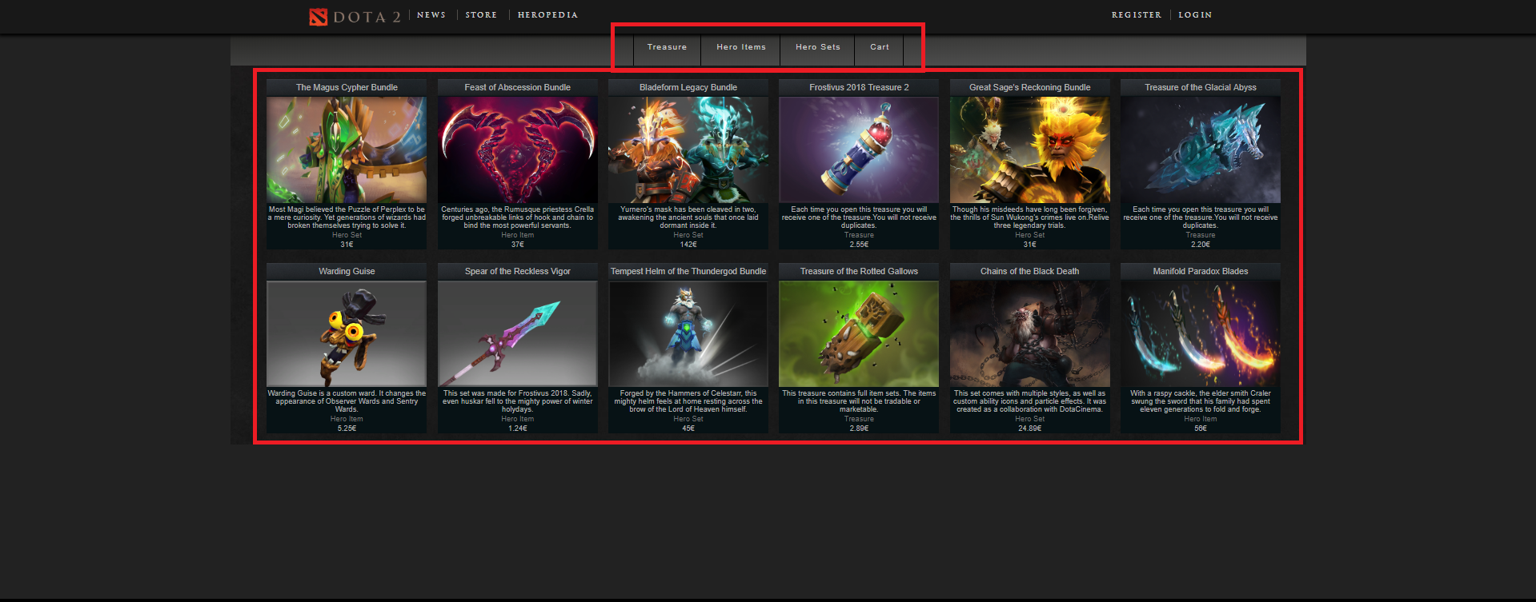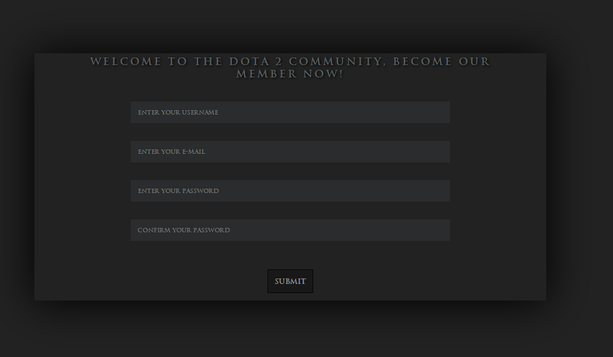

Kod za pravljenje stranica, html :

Index.html

<!DOCTYPE html>

<html lang="en">

<head>

<meta charset="UTF-8">

<meta name="viewport" content="width=device-width, initial-scale=1.0">

<meta http-equiv="X-UA-Compatible" content="ie=edge">

<link rel="stylesheet" href="css/style.css" type="text/css">

<link rel="icon" href="images/icon.png">

<link href="https://fonts.googleapis.com/css?family=B612" rel="stylesheet">

<script src="https://ajax.aspnetcdn.com/ajax/jQuery/jquery-3.3.1.min.js"></script>

<link rel="stylesheet" href="https://use.fontawesome.com/releases/v5.7.2/css/all.css" integrity="sha384-fnmOCqbTlWIlj8LyTjo7mOUStjsKC4pOpQbqyi7RrhN7udi9RwhKkMHpvLbHG9Sr" crossorigin="anonymous">

<title>Dota - Play for Free</title>

</head>

<body>

<header id="header">

<div id="middleHeading">

<div id="imageHolder">

<a href="index.html"><img src="images/dota2.png" alt="dotka" class="logoImg"></a>

</div>

<i class="fas fa-bars" id="expand"></i>

<ul id="mainUl">

<li><a href="news.html">News</a></li>

<li><a href="store.html">Store</a></li>

<li><a href="heropedia.html">Heropedia</a></li>

</ul>

<div id="loginPlay">

<ul id="userLogin">

<li><a href="sign.html" id="login">Login</a></li>

<li><a href="sign.html" id="register">Register</a></li>

</ul>

</div>

</div>

</header>

<div id="main">

<div id="video">

<iframe id="MainTrailer" src="https://www.youtube.com/embed/SmnqsdeHFT0?rel=0" frameborder="0" allowfullscreen="" data-aspectratio="0.5623028391167192"></iframe>

</div>

<div id="logoBtn">

<img src="http://cdn.dota2.com/apps/dota2/images/blog/play/dota_logo.png">

<h1>"A Modern Multiplayer Masterpiece"</h1>

<h3>- Everyone</h3>

<a class="btnPlay" target="_blank" href="http://store.steampowered.com/app/570/Dota_2/">Play for Free</a>

<h2 id="indexh2">JOIN THE BATTLE. BRING YOUR FRIENDS.</h2>

</div>

</div>

<div id="advertisement">

</div>

<div id="bottomContent">

<div id="carousell">

<div id="carousellMain">

</div>

<div id="navCarousell">

<img src="images/screenshot_02.jpg" class="carousellImage" alt="ss1">

<img src="images/screenshot_03.jpg" class="carousellImage" alt="ss2">

<img src="images/screenshot_04.jpg" class="carousellImage" alt="ss3">

<img src="images/screenshot_08.jpg" class="carousellImage" alt="ss4">

</div>

</div>

</div>

<footer>

<div id="centerFooter">

<a href="documentation.pdf">Documentation</a>

<a href="sitemap.xml">Sitemap</a>

<a href="about.html">About</a>

<p>© Valve Corporation, all rights reserved. Valve, the Valve logo, Steam, the Steam logo, Source, the Source logo, Valve Source and Dota are trademarks and/or registered trademarks of Valve Corporation.</p>

</div>

</footer>

</body>

<script src= "js/index.js"> </script>

<script src="js/storage.js"></script>

</html>

Heropedia.html

<!DOCTYPE html>

<html lang="en">

<head>

<meta charset="UTF-8">

<meta name="viewport" content="width=device-width, initial-scale=1.0">

<meta http-equiv="X-UA-Compatible" content="ie=edge">

<link rel="stylesheet" href="css/style.css" type="text/css">

<link rel="icon" href="images/icon.png">

<link href="https://fonts.googleapis.com/css?family=B612" rel="stylesheet">

<script src="https://ajax.aspnetcdn.com/ajax/jQuery/jquery-3.3.1.min.js"></script>

<title>Heropedia</title>

</head>

<body>

<header id="header">

<div id="middleHeading">

<div id="imageHolder">

<a href="index.html"><img src="images/dota2.png" alt="dotka" class="logoImg"></a>

</div>

<i class="fas fa-bars" id="expand"></i>

<ul id="mainUl">

<li><a href="news.html">News</a></li>

<li><a href="store.html">Store</a></li>

<li><a href="heropedia.html">Heropedia</a></li>

</ul>

<div id="loginPlay">

<ul id="userLogin">

<li><a href="sign.html" id="login">Login</a></li>

<li><a href="sign.html" id="register">Register</a></li>

</ul>

</div>

</div>

</header>

<div id="heroWrap">

<div id="nameRolePlaceholder">

<h2 id="heroNamePut">Chose Your Hero</h2>

<hr class="hrStyle">

<div id="rolePlaceholder">

<p class="white" id="typeAttack"></p>

<p id="rolesChange"></p>

</div>

</div>

<div id="filter">

<p id="filterTag">Filters</p>

<select name="roles" id="roles">

<option selected disabled>By Role</option>

<option>All</option>

</select>

<select name="attackType" id="attacktype">

<option selected disabled>By Attack Type</option>

<option>All</option>

<option>Ranged</option>

<option>Mele</option>

</select>

<select name="heroName" id="heroName">

<option selected disabled>Hero Name</option>

<option>All</option>

</select>

</div>

<div id="heropediaMain">

</div>

</div>

<div id="heroDescr">

<p id="bio">Hero Biography</p>

<p class="smallP" id="heroNameP"></p>

<div id="heroDesc">

</div>

</div>

<footer>

<div id="centerFooter">

<a href="documentation.pdf">Documentation</a>

<a href="sitemap.xml">Sitemap</a>

<a href="about.html">About</a>

<p>© Valve Corporation, all rights reserved. Valve, the Valve logo, Steam, the Steam logo, Source, the Source logo, Valve Source and Dota are trademarks and/or registered trademarks of Valve Corporation.</p>

</div>

</footer>

</body>

<script src="js/heroes.js"></script>

<script src="js/storage.js"></script>

</html>

News.html

<!DOCTYPE html>

<html lang="en">

<head>

<meta charset="UTF-8">

<meta name="viewport" content="width=device-width, initial-scale=1.0">

<meta http-equiv="X-UA-Compatible" content="ie=edge">

<link rel="stylesheet" href="css/style.css" type="text/css">

<link rel="icon" href="images/icon.png">

<link href="https://fonts.googleapis.com/css?family=B612" rel="stylesheet">

<script src="https://ajax.aspnetcdn.com/ajax/jQuery/jquery-3.3.1.min.js"></script>

<link rel="stylesheet" href="https://use.fontawesome.com/releases/v5.7.2/css/all.css" integrity="sha384-fnmOCqbTlWIlj8LyTjo7mOUStjsKC4pOpQbqyi7RrhN7udi9RwhKkMHpvLbHG9Sr" crossorigin="anonymous">

<title>Dota - Play for Free</title>

</head>

<body>

<header id="header">

<div id="middleHeading">

<div id="imageHolder">

<a href="index.html"><img src="images/dota2.png" alt="dotka" class="logoImg"></a>

</div>

<i class="fas fa-bars" id="expand"></i>

<ul id="mainUl">

<li><a href="news.html">News</a></li>

<li><a href="store.html">Store</a></li>

<li><a href="heropedia.html">Heropedia</a></li>

</ul>

<div id="loginPlay">

<ul id="userLogin">

<li><a href="sign.html" id="login">Login</a></li>

<li><a href="sign.html" id="register">Register</a></li>

</ul>

</div>

</div>

</header>

<div id="upperImage">

<div id="midImg">

<img src="http://cdn.dota2.com/apps/dota2/images/blogfiles/2014/trans.gif" width="100%" height="377">

</div>

</div>

<div id="bottomContentNews">

<div id="postPosition">

<div id="postsHolder">

<div id="tabs">

<div id="tab">

<a href="news.html" class="tabs visited" id="generateBlog">

BLOG

</a>

<a class="tabs unvisited" id="generateUpdates">

UPDATES

</a>

<a class="tabs unvisited" id="filterAZ">ORDER A-Z</a>

<a class="tabs unvisited" id="filterDate">ORDER DATE</a>

</div>

</div>

<div id="rightInfo">

<a href="https://store.steampowered.com/app/570/Dota_2/" target="_blank" id="playDota"></a>

</div>

<div id="leftInfo">

</div>

</div>

</div>

</div>

<footer>

<div id="centerFooter">

<a href="documentation.pdf">Documentation</a>

<a href="sitemap.xml">Sitemap</a>

<a href="about.html">About</a>

<p>© Valve Corporation, all rights reserved. Valve, the Valve logo, Steam, the Steam logo, Source, the Source logo, Valve Source and Dota are trademarks and/or registered trademarks of Valve Corporation.</p>

</div>

</footer>

</body>

<script src="js/news.js"></script>

<script src="js/storage.js"></script>

</html>

Store.html

<!DOCTYPE html>

<html lang="en">

<head>

<meta charset="UTF-8">

<meta name="viewport" content="width=device-width, initial-scale=1.0">

<meta http-equiv="X-UA-Compatible" content="ie=edge">

<link rel="stylesheet" href="css/style.css" type="text/css">

<link rel="icon" href="images/icon.png">

<link href="https://fonts.googleapis.com/css?family=B612" rel="stylesheet">

<script src="https://ajax.aspnetcdn.com/ajax/jQuery/jquery-3.3.1.min.js"></script>

<link rel="stylesheet" href="https://use.fontawesome.com/releases/v5.7.2/css/all.css" integrity="sha384-fnmOCqbTlWIlj8LyTjo7mOUStjsKC4pOpQbqyi7RrhN7udi9RwhKkMHpvLbHG9Sr" crossorigin="anonymous">

<title>Dota - Play for Free</title>

</head>

<body>

<header id="header">

<div id="middleHeading">

<div id="imageHolder">

<a href="index.html"><img src="images/dota2.png" alt="dotka" class="logoImg"></a>

</div>

<i class="fas fa-bars" id="expand"></i>

<ul id="mainUl">

<li><a href="news.html">News</a></li>

<li><a href="store.html">Store</a></li>

<li><a href="heropedia.html">Heropedia</a></li>

</ul>

<div id="loginPlay">

<ul id="userLogin">

<li><a href="sign.html" id="login">Login</a></li>

<li><a href="sign.html" id="register">Register</a></li>

</ul>

</div>

</div>

</header>

<div id="storeHolder">

<div id="storeTopBar">

<a class="itemSelection" id="Treasure">Treasure</a>

<a class="itemSelection" id="HeroItem">Hero Items</a>

<a class="itemSelection" id="HeroSet">Hero Sets</a>

<a href="cart.html" class="itemSelection">Cart</a>

</div>

<div id="storeItemsHolder">

</div>

</div>

</div>

<div id="footer">

<footer>

<div id="centerFooter">

<a href="documentation.pdf">Documentation</a>

<a href="sitemap.xml">Sitemap</a>

<a href="about.html">About</a>

<p>© Valve Corporation, all rights reserved. Valve, the Valve logo, Steam, the Steam logo, Source, the Source logo, Valve Source and Dota are trademarks and/or registered trademarks of Valve Corporation.</p>

</div>

</footer>

</div>

</body>

<script src="js/storage.js"></script>

<script src="js/store.js"></script>

</html>

Sign.html

<!DOCTYPE html>

<html lang="en">

<head>

<meta charset="UTF-8">

<meta name="viewport" content="width=device-width, initial-scale=1.0">

<meta http-equiv="X-UA-Compatible" content="ie=edge">

<link rel="stylesheet" href="css/style.css" type="text/css">

<link rel="icon" href="images/icon.png">

<link href="https://fonts.googleapis.com/css?family=B612" rel="stylesheet">

<script src="https://ajax.aspnetcdn.com/ajax/jQuery/jquery-3.3.1.min.js"></script>

<link rel="stylesheet" href="https://use.fontawesome.com/releases/v5.7.2/css/all.css" integrity="sha384-fnmOCqbTlWIlj8LyTjo7mOUStjsKC4pOpQbqyi7RrhN7udi9RwhKkMHpvLbHG9Sr" crossorigin="anonymous">

<title>Dota - Play for Free</title>

</head>

<body>

<header id="header">

<div id="middleHeading">

<div id="imageHolder">

<a href="index.html"><img src="images/dota2.png" alt="dotka" class="logoImg"></a>

</div>

<i class="fas fa-bars" id="expand"></i>

<ul id="mainUl">

<li><a href="news.html">News</a></li>

<li><a href="store.html">Store</a></li>

<li><a href="heropedia.html">Heropedia</a></li>

</ul>

<div id="loginPlay">

<ul id="userLogin">

<li><a href="sign.html" id="login">Login</a></li>

<li><a href="sign.html" id="register">Register</a></li>

</ul>

</div>

</div>

</header>

<div id="mainDiv">

<h3>Welcome to the Dota 2 community, become our member now!</h3>

<div id="signIn">

</div>

</div>

</body>

<footer>

<div id="centerFooter">

<a href="documentation.pdf">Documentation</a>

<a href="sitemap.xml">Sitemap</a>

<a href="about.html">About</a>

<p>© Valve Corporation, all rights reserved. Valve, the Valve logo, Steam, the Steam logo, Source, the Source logo, Valve Source and Dota are trademarks and/or registered trademarks of Valve Corporation.</p>

</div>

</footer>

<script src= "js/loginSystem.js"> </script>

<script src="js/storage.js"></script>

<script src="js/reg.js"></script>

</html>

About.html

<!DOCTYPE html>

<html lang="en">

<head>

<meta charset="UTF-8">

<meta name="viewport" content="width=device-width, initial-scale=1.0">

<meta http-equiv="X-UA-Compatible" content="ie=edge">

<link rel="stylesheet" href="css/style.css" type="text/css">

<link rel="icon" href="images/icon.png">

<link href="https://fonts.googleapis.com/css?family=B612" rel="stylesheet">

<script src="https://ajax.aspnetcdn.com/ajax/jQuery/jquery-3.3.1.min.js"></script>

<link rel="stylesheet" href="https://use.fontawesome.com/releases/v5.7.2/css/all.css" integrity="sha384-fnmOCqbTlWIlj8LyTjo7mOUStjsKC4pOpQbqyi7RrhN7udi9RwhKkMHpvLbHG9Sr" crossorigin="anonymous">

<title>Dota - Play for Free</title>

</head>

<body>

<header id="header">

<div id="middleHeading">

<div id="imageHolder">

<a href="index.html"><img src="images/dota2.png" alt="dotka" class="logoImg"></a>

</div>

<i class="fas fa-bars" id="expand"></i>

<ul id="mainUl">

<li><a href="news.html">News</a></li>

<li><a href="store.html">Store</a></li>

<li><a href="heropedia.html">Heropedia</a></li>

</ul>

<div id="loginPlay">

<ul id="userLogin">

<li><a href="sign.html" id="login">Login</a></li>

<li><a href="sign.html" id="register">Register</a></li>

</ul>

</div>

</div>

</header>

<div id="aboutCreator">

<h1>About The Creator</h1>

<img src="images/f1.png" alt="creator">

<p>My name is Aleksandar Marjanovic and i made this site as a project for the ICT uni, IT course, Web Programming subject. This is my official third or fourth site, made by using vanila javascript, jquery, css and html, which you can all see in the documentation. The first contact with HTML and CSS was 3 years ago when i worked on a World Of Warcraft emulation. Long time has passed since then but the passion stays the same, appart from programming my passion is gaming and basketball, and i tend to keep up with both, now with added content it's a bit harder.Around 30% of the Terms of Service, which in it's original is on this site, and on the vallhala-realms.com respectively is made by me, and i keep that as a small token of my humble begining as a web developer and a token of appreciation to the people in vallhala realms. Aside from programming i am into basketball and the only thing i can't allow myself to be out of shape. I was born in Belgrade, Serbia, and i currently live in Obrenovac.</p>

</div>

<footer>

<div id="centerFooter">

<a href="documentation.pdf">Documentation</a>

<a href="sitemap.xml">Sitemap</a>

<a href="about.html">About</a>

<p>© Valve Corporation, all rights reserved. Valve, the Valve logo, Steam, the Steam logo, Source, the Source logo, Valve Source and Dota are trademarks and/or registered trademarks of Valve Corporation.</p>

</div>

</footer>

</div>

</body>

</html>

Cart.html

<!DOCTYPE html>

<html lang="en">

<head>

<meta charset="UTF-8">

<meta name="viewport" content="width=device-width, initial-scale=1.0">

<meta http-equiv="X-UA-Compatible" content="ie=edge">

<link rel="stylesheet" href="css/style.css" type="text/css">

<link rel="icon" href="images/icon.png">

<link href="https://fonts.googleapis.com/css?family=B612" rel="stylesheet">

<script src="https://ajax.aspnetcdn.com/ajax/jQuery/jquery-3.3.1.min.js"></script>

<link rel="stylesheet" href="https://use.fontawesome.com/releases/v5.7.2/css/all.css"

integrity="sha384-fnmOCqbTlWIlj8LyTjo7mOUStjsKC4pOpQbqyi7RrhN7udi9RwhKkMHpvLbHG9Sr" crossorigin="anonymous">

<title>Dota - Play for Free</title>

</head>

<body>

<header id="header">

<div id="middleHeading">

<div id="imageHolder">

<a href="index.html"><img src="images/dota2.png" alt="dotka" class="logoImg"></a>

</div>

<i class="fas fa-bars" id="expand"></i>

<ul id="mainUl">

<li><a href="news.html">News</a></li>

<li><a href="store.html">Store</a></li>

<li><a href="heropedia.html">Heropedia</a></li>

</ul>

<div id="loginPlay">

<ul id="userLogin">

<li><a href="sign.html" id="login">Login</a></li>

<li><a href="sign.html" id="register">Register</a></li>

</ul>

</div>

</div>

</header>

<section id="allCartHolder">

<div id="cartItemHolder">

<h1 class="sectionDesc">CART</h1>

<div class="descRow">

<span class="cart itemCart">ITEM</span>

<span class="cart cost">PRICE</span>

<span class="cart quantity">QUANTITY</span>

</div>

<div class="cartItems">

</div>

<div class="totalPrice">

<strong class="total">Total</strong>

<div class="cartTotalPrice">€0</div>

</div>

<button class="buttonPurchase">PURCHASE</button>

<button id="remove" class="buttonPurchase">Remove All Items</button>

</div>

</section>

<div id="footer">

<footer>

<div id="centerFooter">

<a href="documentation.pdf">Documentation</a>

<a href="sitemap.xml">Sitemap</a>

<a href="about.html">About</a>

<p>© Valve Corporation, all rights reserved. Valve, the Valve logo, Steam, the Steam logo, Source, the

Source logo, Valve Source and Dota are trademarks and/or registered trademarks of Valve Corporation.

</p>

</div>

</footer>

</div>

</body>

<script src="js/storage.js"></script>

<script src="js/cart.js"></script>

</html>

Css kod:

@font-face{

font-family: "Trajan";

src:url(fonts/Trajan_Bold.ttf)

}

*{

margin:0;

padding:0;

box-sizing: border-box;

list-style: none;

font-family:"Trajan";

}

.expanded{

height: 120px;

}

option{

background-color:#2a2c2d;

}

select{

width: 150px;

padding: 3px;

font-size: 12px;

background-color: #2a2c2d;

border-top: solid #363939 1px;

border-left: solid #363939 1px;

border-bottom: solid #1b1e1e 1px;

border-right: solid #1b1e1e 1px;

color: #999999;

text-transform: uppercase;

outline:none;

text-align: left;

font-size:11px;

}

p{

display:inline;

}

h2{

color:#cecece;

}

a{

color:#cecece;

text-decoration: none;

font-weight: 100;

font-size: 13px;

letter-spacing: 3px;

}

a:hover{

transition: color 0.4s;

color:white;

}

body{

background-color:#222222;

}

li{

display:inline-block;

}

header{

display:block;

width: 100%;

height: 65px;

position: relative;

background-color:#181818;

box-shadow: 0px 2px 6px 2px black;

-webkit-box-shadow: 0px 2px 6px 2px black;

}

#middleHeading{

margin:0 auto;

width:60%;

height:100%;

}

#imageHolder{

width:180px;

height:100%;

display:block;

float:left;

}

.logoImg{

width:100%;

margin-top:10px;

}

#mainUl{

float:left;

display:block;

padding-top:20px;

margin-left:10px;

}

#mainUl li{

padding-left:15px;

margin-right:15px;

border-left:1px solid #4f4c49;

}

#mainUl li p{

color: #cecece;

text-decoration: none;

font-weight: 100;

font-size: 13px;

letter-spacing: 3px;

cursor:default;

}

#loginPlay{

float:right;

height:100%;

}

#userLogin{

display:block;

padding-top:20px;

margin-left:10px;

}

#userLogin li{

padding-right:15px;

margin-right:15px;

float:right;

}

#userLogin li:last-child{

border-right:1px solid #4f4c49;

}

#dropdown{

cursor: pointer;

}

#heroWrap{

display:block;

margin:70px auto;

height:550px;

width:938px;

padding-top:1px;

box-shadow: 0px 2px 6px 2px black;

-webkit-box-shadow: 0px 2px 15px 5px black;

}

#nameRolePlaceholder{

display:block;

background-color:black;

height:70px;

width:85%;

margin:40px auto;

padding-top:20px;

text-align: center;

border-radius:4px;

}

#nameRolePlaceholder h2{

padding-bottom: 4px;

}

.hrStyle{

display:block;

border:none;

color:white;

height:1px;

background:black;

background: -webkit-gradient(radial, 50% 50%, 0, 50% 50%, 350, from(rgb(209, 209, 209)), to(#222222));

width:90%;

margin:0 auto;

}

#rolePlaceholder{

padding-bottom:10px;

background-color:black;

border-radius: 0px 0px 4px 4px;

}

#rolePlaceholder p{

display:inline-block;

font-size:11px;

color: rgb(143, 143, 143);

}

#rolePlaceholder .white{

color:white;

letter-spacing: 1px;

}

#filter{

margin:0 auto;

width:85%;

display: block;

text-align: center;

}

#filter p{

color:rgb(143, 143, 143);

font-size:11px;

margin-right:7px;

}

#heropediaMain{

width:95%;

margin:20px auto;

}

.heropediaClasses{

width: 33%;

height: 100%;

display:inline-block;

margin-right:2px;

text-align: center;

}

.attributes{

margin:0 auto;

background-repeat: no-repeat;

background-position: 0px 0px;

padding: 6px 10px 15px 40px;

overflow: visible;

text-transform: uppercase;

color: #616363;

font-size: 16px;

}

#strTab{

background-image:url('http://cdn.dota2.com/apps/dota2/images/heropedia/overviewicon_str.png');

}

#agiTab{

background-image:url('http://cdn.dota2.com/apps/dota2/images/heropedia/overviewicon_agi.png');

}

#intTab{

background-image: url('http://cdn.dota2.com/apps/dota2/images/heropedia/overviewicon_int.png');

}

.heroIcons{

text-align: left;

margin-top:20px;

}

.heroIcons a{

letter-spacing: 0px;

}

.heroIcons a:hover{

cursor:pointer;

}

.heroIconsBase{

float: left;

position: relative;

display: block;

width: 59px;

height: 33px;

padding: 4px;

margin-left: 2px;

margin-bottom: 3px;

background-color: #000000;

-moz-border-radius: 3px;

border-radius: 3px;

}

.heroImgHover{

display:none;

border: 3px solid white;

border-radius:3px;

background-color: #000000;

padding:1px;

z-index:3;

top: -19px;

left: -34px;

}

/*hero info styling*/

#heroDescr{

margin:30px auto;

width:938px;

box-shadow: 0px 2px 6px 2px black;

-webkit-box-shadow: 0px 2px 15px 5px black;

text-align: center;

display:block;

}

#heroDescr #bio{

display:inline-block;

color: #9c3627;

font-weight: normal;

text-transform: uppercase;

font-size: 24px;

margin-bottom:20px;

margin-top:20px;

}

.smallP{

display:block;

color:#d9d9d9;

padding-bottom:20px;

font-size:21px;

}

.heroDesc{

margin:20px 0px;

padding-bottom:50px;

color:#939393;

line-height: 25px;

font-family: 'B612', sans-serif;

}

#heroDesc{

width:90%;

margin:0 auto;

display:block;

}

.removedImage{

opacity: .3;

background-color: none;

cursor: default;

padding:0;

}

footer{

width:100%;

background-color:black;

}

#centerFooter{

margin:0 auto;

width:50%;

text-align: center;

}

#centerFooter a{

font-family: Arial, Helvetica, sans-serif;

display:block;

padding-top:20px;

}

#centerFooter p{

color:#939393;

font-family: Arial, Helvetica, sans-serif;

display:block;

padding-top:20px;

}

/*Index */

#main{

width:100%;

background-image: url(http://cdn.dota2.com/apps/dota2/images/blog/play/bg_02.jpg);

-webkit-background-size: cover;

-moz-background-size: cover;

-o-background-size: cover;

background-size: cover;

background-repeat: no-repeat;

background-position: bottom;

box-shadow: inset 0 0 0 1000px rgba(0, 0, 0, 0.534);

margin-top: -8px;

padding-bottom: 10px;

}

#video{

width:70%;

margin:0 auto;

}

#video iframe{

height:600px;

margin:60px auto;

width:100%;

-webkit-box-shadow: 0px 3px 12px 0px rgba(0,0,0,0.75);

-moz-box-shadow: 0px 3px 12px 0px rgba(0,0,0,0.75);

box-shadow: 0px 3px 12px 0px rgba(0,0,0,0.75);

}

#logoBtn{

width:80%;

margin:0 auto;

text-align: center;

margin-top:30px;

}

h1{

margin-top:10px;

font-size: 30px;

letter-spacing: 9px;

color:#A69E99;

}

#indexh2{

text-transform: uppercase;

padding-top: 18px;

font-size: 16px;

color: #5C6163;

text-shadow: 2px 2px 5px #000000;

letter-spacing: 5px;

margin: 40px auto;

}

h3{

font-size: 14px;

color: #5C6163;

padding-top: 4px;

padding-right: 12px;

letter-spacing: 4px;

text-shadow: 2px 2px 5px #000000;

}

.btnPlay{

font-size: 12px;

text-transform: uppercase;

background-color: #111C26;

border: 1px solid #336391;

border-radius: 3px;

display: inline-block;

text-shadow: 2px 2px 5px #000000;

color: #4585C3;

letter-spacing: 6px;

text-align: center;

-o-transition: .3s;

-ms-transition: .3s;

-moz-transition: .3s;

-webkit-transition: .3s;

transition: .3s;

-webkit-box-shadow: 0px 3px 12px 0px rgba(0,0,0,0.75);

-moz-box-shadow: 0px 3px 12px 0px rgba(0,0,0,0.75);

box-shadow: 0px 3px 12px 0px rgba(0,0,0,0.75);

margin: 40px auto;

padding:36px;

}

.ads{

width:100%;

display:flex;

-webkit-background-size: cover;

-moz-background-size: cover;

-o-background-size: cover;

background-size: cover;

}

.placement{

margin:0 auto;

width:80%;

padding: 128px 0 0 643px;

}

.placement p{

font-family: 'B612', sans-serif;

}

.placement .bigOne{

width:100%;

font-size: 34px;

margin-bottom:20px;

}

.placement .textField{

font-size: 22px;

display: block;

line-height: 36px;

text-align: left;

}

.placement .quote{

padding-top:91px;

font-size: 26px;

padding-right: 43px;

text-align: right;

display:block;

}

.placement .quoter{

display:block;

font-size: 22px;

text-align: right;

padding-right: 19px;

padding-left: 0;

padding-bottom:20px;

}

.of1{

background-image:url(http://cdn.dota2.com/apps/dota2/images/blog/play/bg_04.jpg)

}

.of2{

background-image:url(http://cdn.dota2.com/apps/dota2/images/blog/play/bg_05.jpg)

}

.of3{

background-image:url(http://cdn.dota2.com/apps/dota2/images/blog/play/bg_06.jpg)

}

.of2 .placement{

margin-left:200px;

padding: 128px 500px 0 0;

width:60%;

text-align: left;

color:#999999;

}

.fa-bars{

color:#cecece;;

font-size:32px;

padding-top: 16px;

margin-right: 30px;

float:right;

display: none !important;

cursor: pointer;

}

#bottomContent{

width: 100%;

background-image: url(http://cdn.dota2.com/apps/dota2/images/blog/play/bg_02.jpg);

background-size: cover;

background-color: rgb(20, 20, 21);

margin-top: -8px;

padding-bottom: 140px;

background-repeat: no-repeat;

background-position: center bottom;

}

#carousell{

width: 100%;

max-width: 1268px;

margin:0 auto;

}

#carousellMain{

width: 1000px;

height: 560px;

margin:0px auto;

}

#navCarousell{

margin: 50px 11%;

width: 1000px;

height: 140px;

margin-top:100px;

}

#navCarousell img{

width:246px;

display:inline-block;

}

#carousellMain img{

width:100%;

margin-top:50px;

}

#navCarousell img:hover{

border: 2px solid #4585c3;

width:244px;

cursor:pointer;

}

/*News styling*/

#upperImage{

width: 100%;

height: 384px;

background-image:url('http://cdn.dota2.com/apps/dota2/images/blogfiles/bg_five_heroes.jpg');

background-repeat: no-repeat;

background-position: center;

text-align: center;

background-color: #010101

}

#postsHolder{

text-align: left;

background-image: url('http://cdn.dota2.com/apps/dota2/images/blogfiles/2014/content_bg_top.jpg');

background-position: top;

background-repeat: no-repeat;

min-height: 2400px;

position: relative;

padding-top: 2px;

padding-left: 24px;

}

#postPosition{

width: 938px;

margin: 0 auto;

background-image: url('http://cdn.dota2.com/apps/dota2/images/blogfiles/2014/content_bg_repeat.jpg');

background-repeat: repeat-y;

background-position: center 84px;

position: relative;

overflow: auto;

}

#bottomContentNews{

width: 100%;

background-image: url('http://cdn.dota2.com/apps/dota2/images/blogfiles/2014/body_bg_mid.jpg');

background-color: #010101;

background-repeat: no-repeat;

background-position: top center;

overflow: auto;

}

#tabs{

position: relative;

margin-top: -6px;

margin-left: -30px;

width: 659px;

height: 61px;

background-image: url(http://cdn.dota2.com/apps/dota2/images/blogfiles/2014/tabs_bg.png);

background-repeat: no-repeat;

background-position: bottom;

}

.tabs{

display: block;

position: relative;

height: 38px;

padding: 0px 25px;

font-family: arial,helvetica,sans-serif;

font-size: 14px;

background-repeat: repeat-x;

text-align: center;

line-height: 40px;

letter-spacing: 2px;

font-weight: bold;

margin-top: 4px;

color: #0a1a1e;

float: left;

background-image: url(http://cdn.dota2.com/apps/dota2/images/blogfiles/2014/tab_on_ro_bg.png);

border-right:2px solid black;

}

.unvisited{

cursor:pointer;

background-image:none;

text-decoration: none;

color: #cacaca;

text-shadow: -1px -1px 2px rgba(0, 0, 0, 1);

}

#rightInfo{

float: right;

overflow: hidden;

width: 295px;

margin-left: 23px;

margin-top: -30px;

background-repeat: no-repeat;

min-height: 1900px;

}

#leftInfo{

float:left;

width:580px;

min-height: inherit

}

#playDota{

display: block;

width: 264px;

height: 77px;

background-image: url('http://cdn.dota2.com/apps/dota2/images/blogfiles/2014/rightcol_steam_button.jpg');

background-repeat:no-repeat;

margin-left: 14px;

margin-bottom: 8px;

}

.infoPosts{

display: block;

width: 256px;

height: 164px;

margin: 8px 0px 12px 18px;

background-position: top;

-webkit-box-shadow: 0px 0px 5px 1px rgba(0,0,0,0.75);

-moz-box-shadow: 0px 0px 5px 1px rgba(0,0,0,0.75);

box-shadow: 0px 0px 5px 1px rgba(0,0,0,0.75);

}

.infoPosts:hover{

box-shadow: inset 0 0 0 1000px rgba(255, 255, 255, 0.397);

}

.post{

border-bottom: 1px solid gray;

margin-bottom:20px;

padding-bottom:10px;

}

.post p{

display:block;

font-family: 'Radiance', Arial, sans-serif;

font-weight: 100;

color: #7d7d7d;

}

.post .title{

color: #a8babc;

font-family: arial,helvetica,sans-serif;

font-weight: 100;

}

.post .date{

margin-bottom: 24px;

margin-left:5px;

color: #7d7d7d;

font-size: 13px;

line-height: 22px;

padding-left: 4px;

}

.post img{

width:100%;

}

.post .blogs{

font-size: 15px;

margin-bottom: 18px;

line-height: 22px;

}

.patch{

margin-bottom:20px;

}

.disabled{

background-color:rgba(161, 161, 161, 0.432);

cursor:default;

}

.visited{

cursor:pointer;

}

.disabled:hover{

transition:none;

color: #cacaca;

}

/*Sign styling */

#mainDiv{

width: 50%;

height:460px;

margin:180px auto;

box-shadow: 0px 2px 6px 2px black;

-webkit-box-shadow: 0px 2px 76px 2px black;

text-align: center;

}

#mainDiv h3{

font-size: 1.17em;

display:block;

padding-right: 0px;

width: 80%;

margin:0 auto;

}

#signIn{

width:78%;

margin:0 auto;

margin-top:40px;

}

.inputs{

margin:0px auto;

width:80%;

padding: 13px;

background-color: #2a2c2d;

border:none;

outline:none;

text-align: left;

font-size:11px;

transition: all 0.6s;

display: block;

}

.inputs:focus{

box-shadow: 0px 2px 6px 2px black;

-webkit-box-shadow: 0px 2px 6px 2px black;

}

#submit{

margin:30px auto 0px auto;

padding: 13px;

border-radius: 2px;

border: 1px solid black;

background-color: #181818;

color: #999999;

display: block;

cursor: pointer;

}

.hidden{

opacity: 0;

}

#signUsername{

margin-bottom:40px;

}

small{

font-size:10px;

color:rgba(255, 0, 0, 0.568);

margin:10px auto;

display:block;

width:70%;

text-align: left;

}

/* Store css*/

#storeHolder{

background-image: url(http://cdn.dota2.com/apps/dota2/images/store/bg_main.jpg);

width:70%;

margin:0 auto;

height: fit-content;

padding-bottom:20px;

}

#storeTopBar{

height:60px;

width:100%;

display:block;

background-image: linear-gradient(to top left, rgb(85, 85, 85), rgb(39, 39, 37));

text-align: center;

}

.itemSelection{

cursor: pointer;

height:100%;

padding: 27px 25px;

font-family: arial,helvetica,sans-serif;

font-size: 15px;

text-align: center;

line-height: 50px;

letter-spacing: 2px;

border-right:2px solid black;

}

.itemSelection:first-child{

border-left:2px solid black;

}

#storeItemsHolder{

height: 100%;

display:block;

width:100%;

text-align: center;

}

.item{

margin-left:20px;

width: 300px;

background-image: url(http://cdn.dota2.com/apps/dota2/images/store/bg_spotlight.png);

display:inline-block;

margin-top:25px;

}

.itemName{

color:rgb(177, 177, 177);

width: 300px;

height: 33px;

text-align: center;

}

.itemName p{

font-family: Arial, Helvetica, sans-serif;

margin-top:6px;

display:inline-block;

}

.itemImage{

padding: 0;

text-align: center;

cursor: pointer;

position: relative;

width: 300px;

}

.itemImage img{

width: 300px;

height: 200px;

}

.addToCart{

z-index: 4;

font-size: 14px;

text-align: center;

}

.cartItems:last-child{

display:inline-block

}

.cartItems{

margin-bottom:2px;

color:rgb(177, 177, 177);

display:block;

font-family: Arial, Helvetica, sans-serif;

}

.itemsType{

color:rgb(119, 119, 119)

}

.itemsPrice{

display:inline-block;

}

.addToCartBtn img{

width: 20px;

height: 20px;

}

.descRow{

color:rgb(204, 204, 204);

}

/* MEdia queries*/

@media screen and (max-width: 1780px) {

#storeHolder{

width:100%;

}

.item{

margin-left:90px;

}

}

@media screen and (max-width: 1280px) {

#storeHolder{

width:100%;

}

.attributes{

display:none;

}

.heropediaClasses{

display:block;

width:100%;

padding-bottom:20px;

height: fit-content;

}

#heroWrap{

width:100%;

}

#heroDescr{

width:100%;

text-align: center;

}

#nameRolePlaceholder{

width:100%;

}

#mainDiv{

width:100%;

height:fit-content;

}

#mainDiv input{

width: 100%;

}

#centerFooter{

width:100%;

}

#middleHeading {

width: 100%;

}

#video{

width:85%;

}

.placement{

width:100%;

}

.of2 .placement{

width:100%;

}

#carousellMain{

width:100%;

margin-bottom:50px;

}

#navCarousell{

display:none;

}

}

@media screen and (max-width: 1100px){

#postPosition{

text-align: center;

background-color:black;

background:none;

}

#postsHolder{

text-align: center;

background:none;

}

#tabs{

margin:0 auto;

}

#rightInfo{

display: none;

}

#leftInfo{

margin:0 auto;

float:none;

}

#bottomContentNews{

background:none;

background-color: #181818;

}

#video{

width:98%;

}

.of2 .placement .bigOne{

text-align: center;

font-size:32px;

margin-bottom:40px;

display:block;

}

.of2 .placement{

width:100%;

padding:0px;

margin-left:0px;

}

.placement .textField{

text-align: center;

}

.of2 .placement .textField{

text-align: center;

}

.placement{

width:100%;

padding:0px;

}

.placement .bigOne{

text-align: center;

margin-bottom:40px;

display:block;

}

.ads{

box-shadow: inset 0 0 0 1000px rgba(116, 116, 116, 0.562);

}

}

#footer footer{

margin-top:290px;

}

/*Cart Items*/

#allCartHolder{

max-width: 80%;

margin: 0 auto;

padding: 0 1.5em;

}

#cartItemHolder{

width:65%;

margin:60px auto;

font-weight: normal;

color: #333;

text-align: center;

}

.sectionDesc{

margin:0 auto;

}

.cart{

display: inline-flex;

align-items: center;

border-bottom: 1px solid black;

padding-bottom: 10px;

margin-top: 10px;

}

.itemCart{

width: 36%;

}

.cost{

width: 20%;

color: rgb(204, 204, 204);

}

.quantity{

width: 35%;

}

.oneRow{

display: flex;

width:94%;

margin:10px auto;

}

.cartItemPart{

display: flex;

align-items: center;

border-bottom: 1px solid black;

padding-bottom:10px;

margin:10px auto;

}

.image-cart{

width:38.5%;

}

.price-cart{

width: 20%;

}

.quantity-cart{

width: 35%;

}

.cart-input{

height: 34px;

width: 50px;

border-radius: 5px;

border: 1px solid rgb(0, 0, 0);

background-color: #eee;

color: #333;

padding: 0;

text-align: center;

font-size: 1.2em;

margin-right: 25px;

}

.buttonRemove{

cursor: pointer;

padding: .67em .67em;

color: white;

background-color: rgb(73, 73, 73);

border: none;

border-radius: .3em;

font-weight: bold;

}

.totalPrice{

color:rgb(204, 204, 204);

text-align: end;

margin-top: 10px;

margin-right: 10px;

}

.buttonPurchase{

display: block;

margin: 40px auto 40px auto;

cursor: pointer;

padding: .47em .47em;

color: white;

background-color: rgb(0, 0, 0);

border: none;

border-radius: .1em;

font-weight: bold;

font-size: 1.35em;

}

.buttonPurchase:last-child{

margin: 0px auto 80px auto;

}

/*About*/

#aboutCreator{

width:100%;

height:800px;

text-align: center;

}

#aboutCreator img{

margin:0 auto;

margin-top:50px;

display:block;

}

#aboutCreator p{

width:60%;

color: rgb(204, 204, 204);

margin:20px auto;

letter-spacing: 0px;

}

#aboutCreator h1{

margin-top:40px;

}

@media screen and (max-width: 922px) {

.item{

margin-left:10px;

}

#leftInfo{

width:100%;

}

#postPosition{

width:100%;

}

#postsHolder{

padding:0;

}

#tabs{

width:100%;

}

.tabs{

padding:0 15px;

font-size:8px;

}

#imageHolder{

width:170px;

}

header a{

font-size:12px;

}

h1{

font-size:18px;

}

}

@media screen and (max-width: 722px) {

filter p{

display:none;

}

#imageHolder{

width:170px;

}

#mainUl{

display:none;

}

.fa-bars{

display:block !important;

}

}

@media screen and (max-width:522px) {

.itemSelection{

border:none;

}

.itemSelection:first-child{

border:none;

}

.item{

margin:0 auto;

}

#logoBtn img{

width:100%;

}

#filter{

width:100%;

display:flex;

}

#filter #filterTag{

display:none;

}

#heroWrap{

height: 700px;

}

#imageHolder{

display: none;

}

.placement .quote{

font-size: 12px;

}

.placement .quoter{

font-size: 12px;

}

#loginPlay{

float:left;

}

.of2 .placement .bigOne{

font-size: 22px;

}

.placement .bigOne{

font-size: 22px;

}

.placement .textField{

font-size: 12px;

}

}

Js kod:

Heroes.js

$(document).ready(function(){

$(document).ready(function(){

$('#expand').click(function(){

if($('#header').height() == 120){

$('#header').stop().animate({height:"65px"})

$('#mainUl').stop().fadeIn().css({"display":"none"})

}else{

$('#header').stop().animate({height:"120px"})

$('#mainUl').stop().fadeIn().css({"display":"flex", "margin-bottom":"20px"}).children().css({"border-left":"none", "padding-left":"0px"})

}

});

});

$.ajax('js/heroes.json', {

method: "GET",

dataType: "json",

success: function (heroes) {

//here i write stuff for heropedia

var getHeroIcons1 = document.getElementsByClassName("heroIcons")[0]

var getHeroIcons2 = document.getElementsByClassName("heroIcons")[1]

var getHeroIcons3 = document.getElementsByClassName("heroIcons")[2]

for (hero of heroes) {

showHeroInfo(event);

heroTag.innerHTML += `<option>${hero.name}</option>`

if (hero.class == "Strength") {

getHeroIcons1.innerHTML += `<a class="heroIconsBase"> <img src="${hero.image}" alt="${hero.name}" class="heroesImg" data-role="${hero.role}" data-type="${hero.type}">

<img src=${hero.imageHover} alt="${hero.name}" class="heroImgHover" data-role="${hero.role}" data-type="${hero.type}">`

} else if (hero.class == "Agility") {

getHeroIcons2.innerHTML += `<a class="heroIconsBase"> <img src="${hero.image}" alt="${hero.name}" class="heroesImg" data-role="${hero.role}" data-type="${hero.type}">

<img src=${hero.imageHover} alt="${hero.name}" class="heroImgHover" data-role="${hero.role}" data-type="${hero.type}">`

} else if (hero.class == "Intelligence") {

getHeroIcons3.innerHTML += `<a class="heroIconsBase"> <img src="${hero.image}" alt="${hero.name}" class="heroesImg" data-role="${hero.role}" data-type="${hero.type}">

<img src=${hero.imageHover} alt="${hero.name}" class="heroImgHover" data-role="${hero.role}" data-type="${hero.type}">`

}

}

//Event listneres for images

for (i = 0; i < getHeroImg.length; i++) {

getBigImage[i].addEventListener("click", showHeroInfo)

getHeroImg[i].addEventListener("mouseover", hideImage)

getBigImage[i].addEventListener("mouseleave", e => returnImage(e.target))

}

roleFilterGet.addEventListener("change", roleFilter)

attackTypeGet.addEventListener("change", filterAttack)

heroNameGet.addEventListener("change", filterName)

},

error: function (err) {

console.error(err);

}})

})

// All the getters and vars

var getPedia = document.getElementById("heropediaMain");

var heroClasses = ["Strength", "Agility", "Intellingence"];

var heroRoles = ["Carry", "Durable", "Support", "Disabler", "Escape", "Nuker", "Jungler", "Initiator", "Pusher"];

var selectTag = document.getElementById("roles");

var heroTag = document.getElementById("heroName");

var getPediaClass = document.getElementsByClassName("heropediaClasses");

var getAttr = document.getElementsByClassName("attributes");

var getHeroDesc = document.getElementById("heroDesc");

//Json placeholders

var getHeroImg = document.getElementsByClassName("heroesImg");

var getBigImage = document.getElementsByClassName("heroImgHover");

var getHeroName = document.getElementById("heroNamePut");

var getHeroRole = document.getElementById("rolesChange");

var getHeroType = document.getElementById("typeAttack");

//Event listeners for filters

var roleFilterGet = document.getElementById("roles")

var attackTypeGet = document.getElementById("attacktype")

var heroNameGet = document.getElementById("heroName")

for (i = 0; i < heroRoles.length; i++) {

selectTag.innerHTML += `<option>${heroRoles[i]}</option>`;

}

for (i = 0; i < heroClasses.length; i++) {

getPedia.innerHTML += `<div class="heropediaClasses" id="${heroClasses[i]}"></div>`

}

//Html code generation

for (i = 0; i < getPediaClass.length; i++) {

var spanAttr = document.createElement("SPAN");

var heroIcons = document.createElement("DIV");

heroIcons.className += "heroIcons"

spanAttr.className += "attributes"

getPediaClass[i].appendChild(spanAttr)

getPediaClass[i].appendChild(heroIcons)

}

getAttr[0].innerText = "STRENGTH";

getAttr[0].id = "strTab";

getAttr[1].innerText = "AGILITY";

getAttr[1].id = "agiTab";

getAttr[2].innerText = "INTELLIGENCE";

getAttr[2].id = "intTab";

function roleFilter(){

let roleFilter = roleFilterGet.options[roleFilterGet.selectedIndex].value

let heroIconsBase = document.getElementsByClassName("heroesImg")

var heroAClass = document.getElementsByClassName("heroIconsBase")

for (let i = 0; i < heroIconsBase.length; i++) {

heroAClass[i].classList.remove("removedImage")

heroIconsBase[i].classList.remove("removedImage")

heroIconsBase[i].addEventListener("click", showHeroInfo);

heroIconsBase[i].addEventListener("mouseover", hideImage)

var heroArray = heroIconsBase[i].dataset.role.split(",")

if (roleFilter == "All") {

heroAClass[i].classList.remove("removedImage")

heroIconsBase[i].classList.remove("removedImage")

heroIconsBase[i].addEventListener("click", showHeroInfo);

heroIconsBase[i].addEventListener("mouseover", hideImage)

}else if(heroArray.includes(roleFilter)){

heroAClass[i].classList.remove("removedImage")

heroIconsBase[i].classList.remove("removedImage");

heroIconsBase[i].addEventListener("click", showHeroInfo);

heroIconsBase[i].addEventListener("mouseover", hideImage);

}

else{

heroAClass[i].classList.add("removedImage")

heroIconsBase[i].classList.add("removedImage");

heroIconsBase[i].removeEventListener("click", showHeroInfo);

heroIconsBase[i].removeEventListener("mouseover", hideImage);

}

}

}

function filterName() {

let nameFilter = $("#heroName option:selected").val();

let heroIconsBase = document.getElementsByClassName("heroesImg")

let heroAClass = document.getElementsByClassName("heroIconsBase")

for (i = 0; i < heroIconsBase.length; i++) {

heroIconsBase[i].classList.remove("removedImage")

heroAClass[i].classList.remove("removedImage")

if (nameFilter === "All") {

heroAClass[i].classList.remove("removedImage")

heroIconsBase[i].classList.remove("removedImage")

heroIconsBase[i].addEventListener("click", showHeroInfo);

heroIconsBase[i].addEventListener("mouseover", hideImage)

} else if (nameFilter != heroIconsBase[i].alt) {

heroAClass[i].classList.add("removedImage")

heroIconsBase[i].classList.add("removedImage");

heroIconsBase[i].removeEventListener("click", showHeroInfo);

heroIconsBase[i].removeEventListener("mouseover", hideImage)

}

}

}

function filterAttack() {

let heroIconsBase = document.getElementsByClassName("heroesImg")

var attackFilter = attackTypeGet.options[attackTypeGet.selectedIndex].value;

let heroAClass = document.getElementsByClassName("heroIconsBase")

for (i = 0; i < heroIconsBase.length; i++) {

//Makes sure the code is a good boy

heroAClass[i].classList.remove("removedImage")

heroIconsBase[i].classList.remove("removedImage")

heroIconsBase[i].addEventListener("click", showHeroInfo);

heroIconsBase[i].addEventListener("mouseover", hideImage)

if (attackFilter === "All") {

heroIconsBase[i].classList.remove("removedImage")

heroIconsBase[i].addEventListener("click", showHeroInfo);

heroIconsBase[i].addEventListener("mouseover", hideImage)

} else if (attackFilter != heroIconsBase[i].dataset.type) {

heroAClass[i].classList.add("removedImage")

heroIconsBase[i].classList.add("removedImage");

heroIconsBase[i].removeEventListener("click", showHeroInfo);

heroIconsBase[i].removeEventListener("mouseover", hideImage)

}

}

}

function showHeroInfo(event) {

$.ajax('js/heroes.json', {

method: "GET",

dataType: "json",

success: function (heroes) {

let heroName = document.getElementById("heroNameP")

let imageHide = event.target;

let getHeroDesc = document.getElementById("heroDesc");

//here i write stuff for heropedia

for (hero of heroes) {

if (imageHide.alt == hero.name) {

getHeroDesc.innerHTML = `<p class="heroDesc" data-name="${hero.name}">${hero.desc}</p>`

document.title = "Heropedia - " + imageHide.alt

heroName.innerText = imageHide.alt;

$('html, body').animate({ scrollTop: $('#heroDesc').offset().top }, 'slow');

}

}

},

error: function (err) {

console.error(err);

}})

}

function hideImage(event) {

let hoverImgGet = document.getElementsByClassName("heroImgHover")

let imageHide = event.target;

var displayed = document.getElementsByClassName("displayed")

for (i = 0; i < hoverImgGet.length; i++) {

if (imageHide.alt == hoverImgGet[i].alt) {

var thatImage = hoverImgGet[i]

thatImage.classList += " displayed"

thatImage.style.display = "block"

thatImage.style.position = "absolute"

thatImage.top = "13px"

getHeroName.innerText = thatImage.alt

getHeroRole.innerText = thatImage.dataset.role.replace(/,/g, ' - ')

getHeroType.innerText = thatImage.dataset.type

}

else if(displayed.length == 2){

setTimeout(()=>returnImage(thatImage), 2)

}

}

}

function returnImage(bigImage) {

let smallImage = document.getElementsByClassName("heroesImg")

var hoverImg = document.getElementsByClassName("heroImgHover")

for (i = 0; i < smallImage.length; i++) {

if (bigImage.alt == smallImage[i].alt) {

getHeroName.innerText = "Chose Your Hero"

getHeroRole.innerText = " "

getHeroType.innerText = " "

}

else{

bigImage.style.display = "none"

}

hoverImg[i].style.display = "none";

hoverImg[i].classList.remove("displayed")

}

}

News.js

var updateBtn = document.getElementById("generateUpdates")

var az = document.getElementById("filterAZ");

var dateFilter = document.getElementById("filterDate");

$(document).ready(function(){

$(document).ready(function(){

$('#expand').click(function(){

if($('#header').height() == 120){

$('#header').stop().animate({height:"65px"})

$('#mainUl').stop().fadeIn().css({"display":"none"})

}else{

$('#header').stop().animate({height:"120px"})

$('#mainUl').stop().fadeIn().css({"display":"flex", "margin-bottom":"20px"}).children().css({"border-left":"none", "padding-left":"0px"})

}

});

});

updateBtn.addEventListener("click", updates)

dateFilter.addEventListener("click", datesFilter)

az.addEventListener("click", filterAZ)

$.ajax('js/blogRight.json', {

method: "GET",

dataType: "json",

success: function (blogs) {

var blogHolder = document.getElementById("rightInfo")

for(blog of blogs){

blogHolder.innerHTML += `<a href="${blog.link}" target="_blank" style="background-image:url('${blog.image}')" class="infoPosts"></a>`

}

},

error: function(){

}});

$.ajax('js/blog.json', {

method: "GET",

dataType: "json",

success: function (blogs) {

var blogHolder = document.getElementById("leftInfo")

for(blog of blogs){

blogHolder.innerHTML += `<div class="post">

<h2 class="title">${blog.title}</h2>

<p class="date">${blog.date}</p>

<div class="imgHolder"><img src="${blog.image}"/></div>

<p class="blogs">${blog.words}</p>

</div>

`

}

}

,

error: function (err) {

console.error(err);

}});

})

function compare(a,b) {

if (a.title < b.title)

return -1;

if (a.title > b.title)

return 1;

return 0;

}

function sortAZ(blogs){

blogs.sort(compare)

}

function filterAZ(){

$.ajax('js/blog.json', {

method: "GET",

dataType: "json",

success: function (blogs) {

sortAZ(blogs);

var blogsHTML = "";

for(blog of blogs){

blogsHTML += `

<div class="post">

<h2 class="title">${blog.title}</h2>

<p class="date">${blog.date}</p>

<div class="imgHolder"><img src="${blog.image}"/></div>

<p class="blogs">${blog.words}</p>

</div> `

}

$("#leftInfo").html(blogsHTML);

},

error: function (err) {

console.error(err);

}});

}

function updates(){

var blog = document.getElementById("generateBlog")

blog.classList.remove("visited")

blog.classList.add("unvisited")

updateBtn.classList.add("visited")

updateBtn.classList.remove("unvisited")

dateFilter.classList.add("disabled")

dateFilter.removeEventListener("click", datesFilter)

az.classList.add("disabled");

az.removeEventListener("click",filterAZ)

$.ajax('js/updates.json', {

method: "GET",

dataType: "json",

success: function (updates) {

blogsHTML = ""

for(update of updates){

blogsHTML += `<div class="post">

<h2 class="title">${update.title}</h2>

<p class="date">${update.date}</p>

<div class="imgHolder"><p class="patch">${update.patch}</p></div>

<p class="blogs">${update.data}</p>

</div>

`

}

$("#leftInfo").html(blogsHTML);

}

,

error: function (err) {

console.error(err);

}});

}

function compareDate(a, b){

if(a.date > b.date){

return -1

} else if (b.date > a.date){

return 1

}else{

return 0

}

}

function sortDate(blogs){

blogs.sort(compareDate)

}

function datesFilter(){

$.ajax('js/blog.json', {

method: "GET",

dataType: "json",

success: function (blogs) {

sortDate(blogs);

console.log(dateGet)

var blogsHTML = "";

for(blog of blogs){

var dateGet = new Date(blogs.date)

blogsHTML += `

<div class="post">

<h2 class="title">${blog.title}</h2>

<p class="date">${blog.date}</p>

<div class="imgHolder"><img src="${blog.image}"/></div>

<p class="blogs">${blog.words}</p>

</div> `

}

$("#leftInfo").html(blogsHTML);

},

error: function (err) {

console.error(err);

}});

}

Storage.js

var login = document.getElementById("login");

var register = document.getElementById("register");

function setLocal(event) {

if (event.target.id == "login") {

localStorage.setItem("userClick", "login");

} else if (event.target.id == "register") {

localStorage.setItem("userClick", "register");

}

}

login.addEventListener("click", setLocal)

register.addEventListener("click", setLocal)

store.js

$(document).ready(function () {

$(document).ready(function () {

$('#expand').click(function () {

if ($('#header').height() == 120) {

$('#header').stop().animate({ height: "65px" })

$('#mainUl').stop().fadeIn().css({ "display": "none" })

} else {

$('#header').stop().animate({ height: "120px" })

$('#mainUl').stop().fadeIn().css({ "display": "flex", "margin-bottom": "20px" }).children().css({ "border-left": "none", "padding-left": "0px" })

}

});

});

})

$.ajax('js/storeItems.json', {

method: "GET",

dataType: "json",

success: function (items) {

var itemHolder = document.getElementById("storeItemsHolder")

for (item of items) {

itemHolder.innerHTML += `<div class="item">

<div class="itemName">

<p>${item.title}</p>

</div>

<div class="itemImage">

<a><img src="${item.image}" alt="${item.image}"></a>

</div>

<div class="addToCart comparison">

<p class="cartItems itemsName">${item.description}</p>

<p class="cartItems itemsType">${item.type}</p>

<p class="cartItems itemsPrice">${item.price}</p><p class="cartItems">€</p>

</div>

</div>`

}

var cartItems = document.getElementsByClassName("itemImage");

for (i = 0; i < cartItems.length; i++) {

cartItems[i].addEventListener("click", addToLocal)

}

function addToLocal(event) {

}

},

error: function (err) {

console.log(err)

}

});

var heroSet = document.getElementById("HeroSet")

var heroItem = document.getElementById("HeroItem")

var treasure = document.getElementById("Treasure")

var type = document.getElementsByClassName("itemsType")

heroSet.addEventListener("click", filterSets)

heroItem.addEventListener("click", filterItems)

treasure.addEventListener("click", filterTreasure)

function filterItems() {

$.ajax('js/storeItems.json', {

method: "GET",

dataType: "json",

success: function (items) {

var itemHolder = document.getElementById("storeItemsHolder")

itemHolder.innerHTML = " "

for (item of items) {

if (item.type == "Hero Item") {

itemHolder.innerHTML += `<div class="item">

<div class="itemName">

<p>${item.title}</p>

</div>

<div class="itemImage">

<a><img src="${item.image}" alt="${item.image}"></a>

</div>

<div class="addToCart comparison">

<p class="cartItems itemsName">${item.description}</p>

<p class="cartItems itemsType">${item.type}</p>

<p class="cartItems itemsPrice">${item.price}</p><p class="cartItems">€</p>

</div>

</div>`

}

}

},

error: function (err) {

console.log(err)

}

});

}

function filterSets() {

$.ajax('js/storeItems.json', {

method: "GET",

dataType: "json",

success: function (items) {

var itemHolder = document.getElementById("storeItemsHolder")

itemHolder.innerHTML = " "

for (item of items) {

if (item.type == "Hero Set") {

itemHolder.innerHTML += `<div class="item">

<div class="itemName">

<p>${item.title}</p>

</div>

<div class="itemImage">

<a><img src="${item.image}" alt="${item.image}"></a>

</div>

<div class="addToCart comparison">

<p class="cartItems itemsName">${item.description}</p>

<p class="cartItems itemsType">${item.type}</p>

<p class="cartItems itemsPrice">${item.price}</p><p class="cartItems">€</p>

</div>

</div>`

}

}

},

error: function (err) {

console.log(err)

}

});

}

function filterTreasure() {

$.ajax('js/storeItems.json', {

method: "GET",

dataType: "json",

success: function (items) {

var itemHolder = document.getElementById("storeItemsHolder")

itemHolder.innerHTML = " "

for (item of items) {

if (item.type == "Treasure") {

itemHolder.innerHTML += `<div class="item">

<div class="itemName">

<p>${item.title}</p>

</div>

<div class="itemImage">

<a><img src="${item.image}" alt="${item.image}"></a>

</div>

<div class="addToCart comparison">

<p class="cartItems itemsName">${item.description}</p>

<p class="cartItems itemsType">${item.type}</p>

<p class="cartItems itemsPrice">${item.price}</p><p class="cartItems">€</p>

</div>

</div>`

}

}

},

error: function (err) {

console.log(err)

}

});

}

Reg.js

$(document).ready(function(){

$(document).ready(function(){

$('#expand').click(function(){

if($('#header').height() == 120){

$('#header').stop().animate({height:"65px"})

$('#mainUl').stop().fadeIn().css({"display":"none"})

}else{

$('#header').stop().animate({height:"120px"})

$('#mainUl').stop().fadeIn().css({"display":"flex", "margin-bottom":"20px"}).children().css({"border-left":"none", "padding-left":"0px"})

}

});

});

})

loginSystem.js

var signWindow = document.getElementById("signIn")

var input = document.createElement("INPUT")

input.type = "text";

input.name = "username"

input.placeholder = "Enter your username"

var inputPw = document.createElement("INPUT")

inputPw.type = "password"

var submitBtn = document.createElement("BUTTON")

submitBtn.type = "button"

submitBtn.id = "submit"

submitBtn.innerText = "Submit"

var eMail = document.createElement("INPUT")

eMail.type = "e-mail"

var pwConfirm = document.createElement("INPUT")

pwConfirm.type = "password"

var unameCheck = document.createElement("SMALL")

var eMailCheck = document.createElement("SMALL")

var pwCheck = document.createElement("SMALL")

var pwCompare = document.createElement("SMALL")

var storage = localStorage.getItem("userClick")

var allInput = document.getElementsByTagName("INPUT");

var allSmalls = document.getElementsByTagName("SMALL")

if (storage == "login") {

signWindow.appendChild(input)

input.id = "signUsername"

signWindow.appendChild(inputPw)

inputPw.id = "signPassword"

inputPw.name = "password"

inputPw.placeholder = "Enter your password"

signWindow.appendChild(submitBtn)

}

else if (storage == "register") {

signWindow.appendChild(input)

signWindow.appendChild(unameCheck)

input.id = "registerUsername"

signWindow.appendChild(eMail)

signWindow.appendChild(eMailCheck)

eMail.placeholder = "Enter your E-mail"

eMail.id = "registerEmail"

signWindow.appendChild(inputPw)

signWindow.appendChild(pwCheck)

inputPw.id = "registerPassword"

inputPw.name = "password"

inputPw.placeholder = "Enter your password"

signWindow.appendChild(pwConfirm)

signWindow.appendChild(pwCompare)

pwConfirm.id = "passwordConfirm"

pwConfirm.name = "passwordConfirm"

pwConfirm.placeholder = "Confirm your password"

signWindow.appendChild(submitBtn)

pwCompare.id = "paraConfPass"

pwCompare.innerText = "Your passwords do not match"

eMailCheck.innerText = "E-mail of incorrect format"

eMailCheck.id = "paraEmail"

unameCheck.id = "paraUsName"

unameCheck.innerText = "Username of incorrect format"

pwCheck.id = "paraPass"

pwCheck.innerText= "Password must have at least 8 characters, one letter and a number"

}

for(i=0; i< allInput.length; i++){

allInput[i].classList = "inputs"

}

for(i=0; i< allSmalls.length; i++){

allSmalls[i].classList = "hidden"

}

$(document).ready(function(){

var regeExEmail =/^\w+([\.-]\w+)*@\w+([\.-]?\w+)*(\.\w{2,4})+$/

var usernameRegex = /^([a-zA-Z]{3,16})$/

//Minimum eight characters, at least one letter and one number:

var passwordRegex = /^(?=.*[A-Za-z])(?=.*\d)[A-Za-z\d]{8,}$/

$('#registerUsername').on('keypress keydown keyup',function(){

if (!$(this).val().match(usernameRegex)) {

$('#paraUsName').removeClass('hidden');

$('#paraUsName').show();

}

else{

$('#paraUsName').addClass('hidden');

}

});

$('#registerPassword').on('keypress keydown keyup',function(){

if (!$(this).val().match(passwordRegex)) {

$('#paraPass').removeClass('hidden');

$('#paraPass').show();

}

else{

$('#paraPass').addClass('hidden');

}

});

$('#registerEmail').on('keypress keydown keyup',function(){

if (!$(this).val().match(regeExEmail)) {

$('#paraEmail').removeClass('hidden');

$('#paraEmail').show();

}

else{

$('#paraEmail').addClass('hidden');

}

});

$('#passwordConfirm').on('keypress keydown keyup', function(){

if($('#registerPassword').val() == $('#passwordConfirm').val()){

$('#paraConfPass').addClass('hidden');

}else{

$('#paraConfPass').removeClass('hidden');

$('#paraConfPass').show();

}

});

})

Index.js

$.ajax('js/baseDesc.json', {

method: "GET",

dataType: "json",

success: function (desc) {

var advertHolderGet = document.getElementById("advertisement")

var adder = 0

for (description of desc) {

adder++

advertHolderGet.innerHTML += `<div class="ads of${adder}">

<div class="placement">

<p class="bigOne">${description.title}</p>

<p class="textField">${description.description}</p>

<p class="quote">"${description.quote}"</p>

<p class="quoter">${description.qoter}</p>

</div>

`

}

},

error: function () {

}

});

var slideImages = document.getElementsByClassName("carousellImage");

var mainImage = document.getElementById("carousellMain")

mainImage.innerHTML = `<img src="${slideImages[0].src}" alt="${slideImages[0].alt}"/>`

for (i = 0; i < slideImages.length; i++) {

slideImages[i].addEventListener("click", showImage);

}

function showImage(event) {

mainImage.innerHTML = `<img src="${event.target.src}" alt="${event.target.alt}"/> `

}

var images = document.getElementsByClassName("carousellImage")

function showImageZoom() {

mainImage.innerHTML = ""

for (i = 0; i < images.length; i++) {

mainImage.innerHTML += `<img src="${images[i].src}" alt="${images[i].alt}" class="newImages"/>`

}

}

var slideIndex = 0;

function shuffleImages() {

var i;

var x = document.getElementsByClassName("newImages");

for (i = 0; i < x.length; i++) {

x[i].style.display = "none";

}

slideIndex++;

if (slideIndex > x.length) { slideIndex = 1 }

x[slideIndex - 1].style.display = "block";

setTimeout(shuffleImages, 2000);

}

var windowWidth = window.matchMedia("(max-width: 1280px)");

function matchWindow() {

if (windowWidth.matches) {

showImageZoom();

shuffleImages();

}

}

matchWindow();

$(document).ready(function(){

$('#expand').click(function(){

if($('#header').height() == 120){

$('#header').stop().animate({height:"65px"})

$('#mainUl').stop().fadeIn().css({"display":"none"})

}else{

$('#header').stop().animate({height:"120px"})

$('#mainUl').stop().fadeIn().css({"display":"flex", "margin-bottom":"20px"}).children().css({"border-left":"none", "padding-left":"0px"})

}

});

});

2 Organizacija

2.1 Sema Organizacije

cart

about

store

Index

heropedia

sign

news

2.2 Sitemap

<?xml version="1.0" encoding="UTF-8"?>

<urlset xmlns="http://www.sitemaps.org/schemas/sitemap/0.9">

<loc>https://thehandofking.github.io/dota2/</loc>

<lastmod>2019-03-14T13:48:51+00:00</lastmod>

<priority>1.00</priority>

</url>

<url>

<loc>https://thehandofking.github.io/dota2/index.html</loc>

<lastmod>2019-03-14T13:48:51+00:00</lastmod>

<priority>0.80</priority>

</url>

<url>

<loc>https://thehandofking.github.io/dota2/news.html</loc>

<lastmod>2019-03-14T13:48:51+00:00</lastmod>

<priority>0.80</priority>

</url>

<url>

<loc>https://thehandofking.github.io/dota2/store.html</loc>

<lastmod>2019-03-14T13:48:51+00:00</lastmod>

<priority>0.80</priority>

</url>

<url>

<loc>

https://thehandofking.github.io/dota2/heropedia.html

</loc>

<lastmod>2019-03-14T13:48:51+00:00</lastmod>

<priority>0.80</priority>

</url>

<url>

<loc>https://thehandofking.github.io/dota2/sign.html</loc>

<lastmod>2019-03-14T13:48:51+00:00</lastmod>

<priority>0.80</priority>

</url>

<url>

<loc>https://thehandofking.github.io/dota2/about.html</loc>

<lastmod>2019-03-14T13:48:51+00:00</lastmod>

<priority>0.80</priority>

</url>

<url>

<loc>https://thehandofking.github.io/dota2/cart.html</loc>

<lastmod>2019-03-14T13:48:51+00:00</lastmod>

<priority>0.64</priority>

</url>

</urlset>